**MÓDULO 5 – MIC014 – AULA 5**

**Alunos: Wesley Silva Araújo, Lucas Gabriel Rocha Constancio**

**DATA: 13/12/2024**

**Artefato 1 – Repositório Git:**

**Link:** <https://github.com/lucasrocha777/HandsON-Maloca-das-iCoisas---IOT>

**Organograma:**

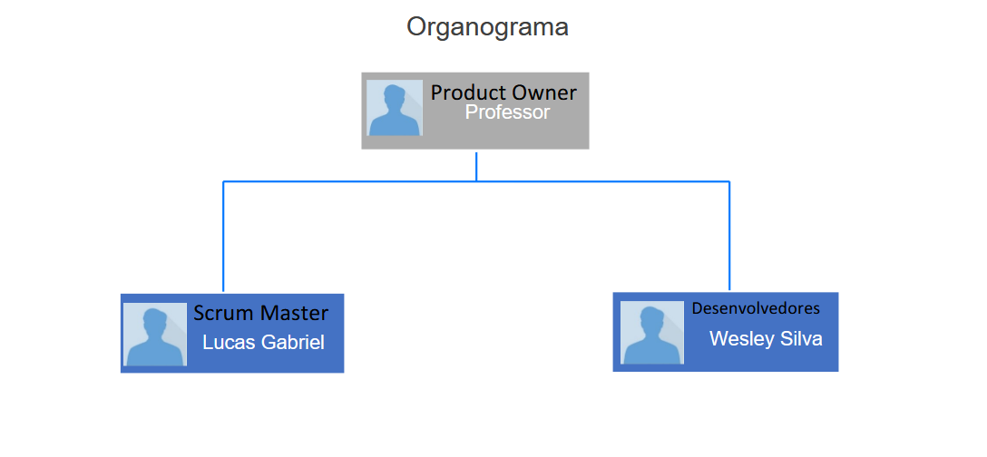

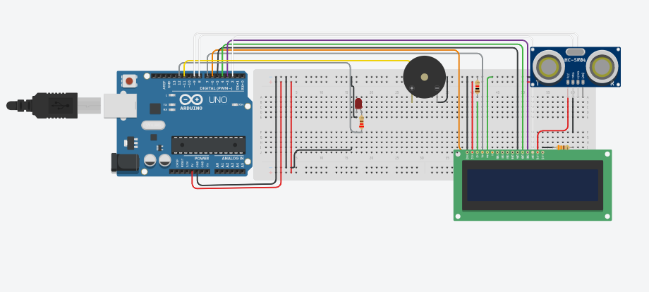**Artefato 2 – Circuito:**